 | 12 ATAR Physics  Circular Motion Validation 4.0%  Term 4 - 2017

Student name:

Experimental outline:

When the plastic tube is moved in a small circle above your head, the rubber cork moves around in a horizontal circle at the end of a string that passes through the tube and has a mass hanger with slotted masses suspended from its lower end. | 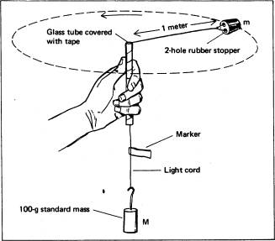

Experimental data: Table 1

 | Radius (m) | Time for 10 revolutions (s) |  | Period (s) | Period² ( )
 |  | Trial 1 | Trial 2
1 | 0.20 | 2.03 | 2.25
2 | 0.34 | 2.61 | 2.55
3 | 0.42 | 3.17 | 3.22
4 | 0.49 | 3.41 | 3.59
5 | 0.53 | 3.54 | 3.64
6 | 0.69 | 3.90 | 3.71
7 | 0.75 | 4.22 | 4.39
8 | 1.02 | 5.09 | 5.05

1. The mass of the rubber stopper was measured as 22.6 grams. Write the correct mass in kg. (1 mark) | kg

2. Complete table 1, rows 2 to 7, for period and period². (4 marks)

3. Complete table 1, rows 1 and 8, for period and period². Write the values of period² using the correct significant figures. (3 marks)

4. Use the data from table 1 to sketch a graph of radius (r) versus period² (T²) on the graph paper provided on the next page.

- Show appropriate labels and units. (2 marks)

- Carefully plot the data from table1. (3 marks)

- Sketch the best-fit line for this data. (2 marks)

5. Calculate the gradient of your graph.

- Show the points used on the graph. (1 mark)

- Calculate the gradient of the line including correct units. (4 marks)

- Write the equation of the straight line below. (3 marks)

6. Why have we chosen to graph r v’s T² and not r v’s T? (3 marks)

7. What can you say about the relationship between r and T²? (3 marks)

Graph of radius (m) versus period² (T²)

8. Calculate the speed of the 2-holed rubber stopper for the first data point of table 1. (3 marks)

9. Calculate the centripetal force (F_{c}) acting on the 2-holed rubber stopper for the first data point of table 1. (3 marks)

10. Given that the mass of the slotted masses is 350 grams, compare the value of F_{c} (above) to that of the weight. Express the comparison value as a percentage difference. (5 marks)

11. The three main formulae used in this experiment are:

 | v = | 2πr | F_{c} = | Mv² | F = | mg
 |  | T |  | r

- Use these to show: (4 marks)

 | r = | mg | T²
 |  | 4π²M

Where M = mass of stopper and m = slotted masses

- Use the formula shown in 11(a) to calculate a theoretical value for the gradient and use this value to compare with the value calculated in 5(b). Express the difference as percentage value. (4 marks)

12. Briefly explain why 10 revolutions were used. (2 marks)

13. List two sources of error that you encountered during this experiment and explain how they affected your results. (4 marks)

